Millersmowingmovingandmore@gmail.com 307-575-5797
Employment Application Form
PLEASE COMPLETE ALL PAGES |  |  |  |  |  | Date
Name

Last First Middle
Present address

Number Street City State Zip
Date of Birth |  |  | Social Security  No. _______ – _____ – _________
Telephone ( ) Alt. Phone: ( )
Facebook: yes/no (Optional)
Email: (Optional)
Position applied for:  Salary desired: |  |  |  | Days/hours available to work  No Pref Thur  Mon Fri  Tue Sat  Wed
Employment desired FULL-TIME ONLY PART-TIME ONLY FULL- OR PART-TIME
When available for work? Do you smoke? Yes No
Are you a citizen of the United States? Yes No If no, are you authorized to work in the U.S.? Yes No
Emergency Contact 1

Name Phone Mobile
Emergency Contact 2

Name Phone Mobile

Education
High School attended: | High School?  Did you graduate?  Yes No | College / University  Did you graduate?  Yes No |  |  | Business / Trade School  Did you graduate?  Yes No |  |  | Other (specify):
Criminal Record
HAVE YOU EVER BEEN CONVICTED OF A CRIME? No Yes
If yes, explain number of conviction(s), nature of offense(s) leading to conviction(s), how recently such offense(s) was/were committed, sentence(s) imposed, and type(s) of rehabilitation.
Driving Record
DO YOU HAVE A VALID DRIVER’S LICENSE? Yes No
Are you proficient at pulling a trailer? Yes No Somewhat
What is your means of transportation to work?
Driver’s license
number State of issue _______ Operator Commercial (CDL)
Expiration date
Have you had any accidents during the past three years? Yes No |  |  |  |  |  |  | How many?
Have you had any moving violations during the past three years? Yes No |  |  |  |  |  |  | How Many?

General Experience and abilities
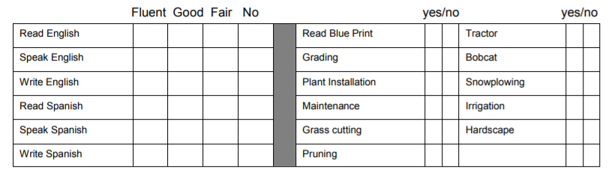
Color Blind
Landscape Experience
Describe landscaping experience (i.e. lawn installations, irrigation, maintenance, pruning, planting, retaining walls, etc.)
Describe equipment you are familiar with.
Snow Removal Experience
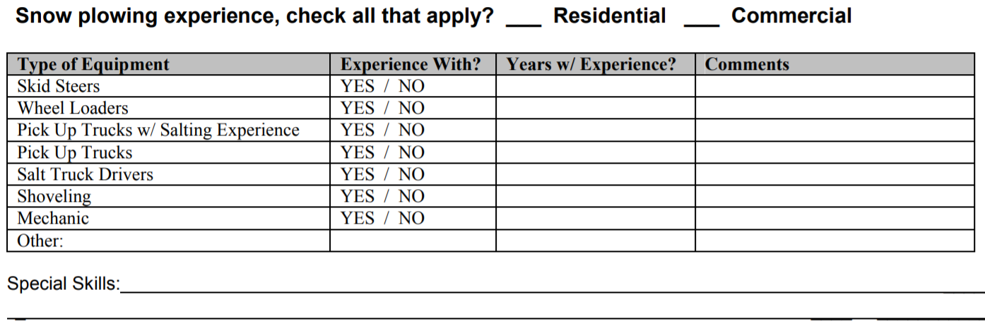

Is there any reason you may or not be able to perform the physical tasks of mowing or shoveling? Yes / No (explain below)

Work Experience | Please list your work experience for the past five years beginning with your most recent job held.  If you were self-employed, give firm name. Attach additional sheets if necessary.
Name of employer  Address |  |  | Name of last supervisor | Employment dates | Pay or salary
City, State, Zip Code  Phone number |  |  |  | From  To | Start  Final
 |  |  | Your last job title
Reason for leaving (be specific)
List the jobs you held, duties performed, skills used or learned, advancements or promotions while you worked at this company.
Name of employer  Address |  |  | Name of last supervisor | Employment dates | Pay or salary
City, State, Zip Code  Phone number |  |  |  | From  To | Start  Final
 |  |  | Your Last Job Title
Reason for leaving (be specific)
List the jobs you held, duties performed, skills used or learned, advancements or promotions while you worked at this company.
Name of employer  Address |  |  | Name of last supervisor | Employment dates | Pay or salary
City, State, Zip Code  Phone number |  |  |  | From  To | Start  Final
 |  |  | Your last job title
Reason for leaving (be specific)
List the jobs you held, duties performed, skills used or learned, advancements or promotions while you worked at this company.
Name of employer  Address |  |  | Name of last supervisor | Employment dates | Pay or salary
City, State, Zip Code  Phone number |  |  |  | From  To | Start  Final
 |  |  | Your last job title
Reason for leaving (be specific)
List the jobs you held, duties performed, skills used or learned, advancements or promotions while you worked at this company.
May we contact your present or past employers? Yes No
References
Full Name |  | Company | Position | Relationship | Phone
Full Name |  | Company | Position | Relationship | Phone
Full Name |  | Company | Position | Relationship | Phone

PLEASE READ CAREFULLY
APPLICATION FORM WAIVER
In exchange for the consideration of my job application by Miller’s Mowing Moving and More (hereinafter called “the Company”), I agree that:
Neither the acceptance of this application nor the subsequent entry into any type of employment relationship, either in the position applied for or any other position, and regardless of the contents of employee handbooks, personnel manuals, benefit plans, policy statements, and the like as they may exist from time to time, or other Company practices, shall serve to create an actual or implied contract of employment, or to confer any right to remain an employee of Miller’s Mowing Moving and More and Landscaping or otherwise to change in any respect the employment-at-will relationship between it and the undersigned, and that relationship cannot be altered except by a written instrument signed by the owner of the Company. Both the undersigned and Miller’s Mowing Moving and More and Landscaping may end the employment relationship at any time, without specified notice or reason. If employed, I understand that the Company may unilaterally change or revise their benefits, policies and procedures and such changes may include reduction in benefits.
I authorize investigation of all statements contained in this application. I understand that the misrepresentation or omission of facts called for is cause for dismissal at any time without any previous notice. I hereby give the Company permission to contact schools, previous employers (unless otherwise indicated), references, and others, and hereby release the Company from any liability as a result of such contract.
I also understand that (1) the Company has a drug and alcohol policy that provides for possible pre-employment testing as well as random and /or periodic testing after employment; (2) consent to and compliance with such policy is a condition of my employment; and (3) continued employment is based on the successful passing of testing under such policy. I further understand that continued employment may be based on the successful passing of job-related physical examinations.
I further understand that my employment with the Company shall be probationary for a period of thirty (30) days, and further that at any time during the probationary period or thereafter, my employment relation with the Company is terminable at will for any reason by either party.
Signature of applicant__________________________________________ Date: ___________________
This Company is an equal employment opportunity employer. We adhere to a policy of making employment decisions without regard to race, color, religion, sex, national origin, citizenship, age or disability. We assure you that your opportunity for employment with this Company depends solely on your qualifications.
Thank you for completing this application form and for your interest in our business.

